Namespace -> Azure.Storage.Blobs

BlobServiceClient(connectionstring)

BlobContainerClient

BlobClient(connectionstring,containerName,blobName)

1. In the Azure portal, use the **Search resources, services, and docs** text box to search for **Storage Accounts**, and then in the list of results, select **Storage Accounts**.
2. On the **Storage accounts** blade, select **+ Create**.
3. On the **Create a storage account** blade, on the **Basics** tab, perform the following actions, and then select **Next: Advanced**:

| **Setting** | **Action** |
| --- | --- |
| **Subscription** drop-down list | Retain the default value |
| **Resource group** section | Use existing, and select **StorageMedia-lod46877267** |
| **Storage account name** text box | enter mediastor46877267 |
| **Region** drop-down list | Select **(US) East US** |
| **Primary service** | No changes |
| **Performance** section | Select the **Standard** option |
| **Redundancy** drop-down list | select **Locally-redundant storage (LRS)** |

1. The following screenshot displays the configured settings on the **Create a storage account blade**.
2. 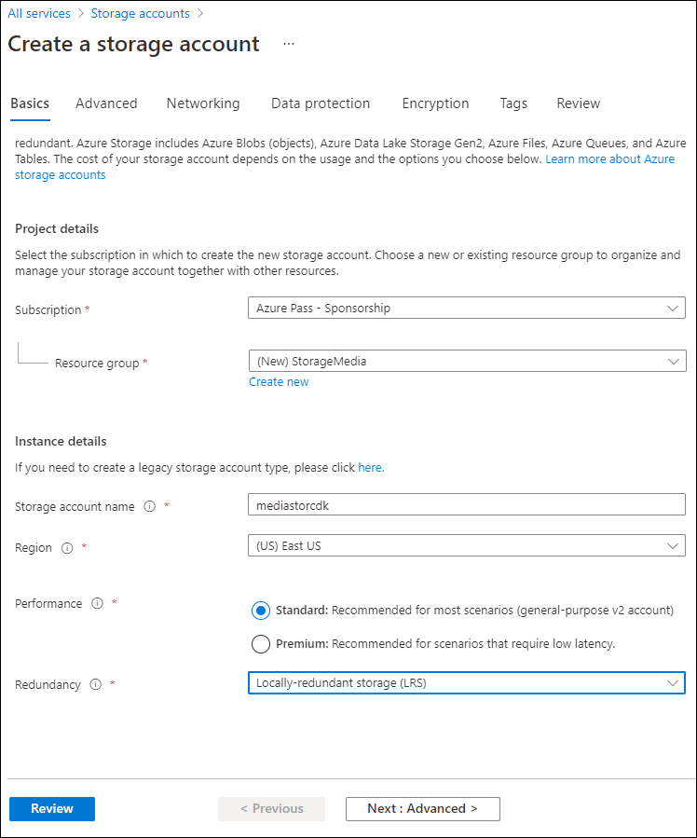
3. On the **Advanced** tab, ensure **Allow enabling anonymous access on individual containers** is checked. Check the setting if it is not enabled, and then select **Review**.
4. On the **Review** tab, review the options that you selected during the previous steps.
5. Select **Create** to create the storage account by using your specified configuration.

**Note**: Wait for the creation task to complete before you move forward with this lab.

1. Select **Go to resource**.
2. On the **Storage account** blade, in the **Settings** section, select the **Endpoints** link.
3. In the **Endpoints** section, copy the value of the **Blob Service** text box to the clipboard.

**Note**: You'll use this endpoint value later in the lab.

1. Open Notepad, and then paste the copied blob service value to Notepad.
2. On the **Storage account** blade, in the **Security + networking** section, select **Access keys**.
3. Copy the **Storage account name** value to the clipboard and then paste it into Notepad.
4. On the **Access keys** blade, select **Show** for either one of the **Key** text boxes. It does not matter which you use, they are interchangeable.
5. Review any one of the keys, and then copy the value of either of the **Key** boxes to the clipboard and then paste it into Notepad.

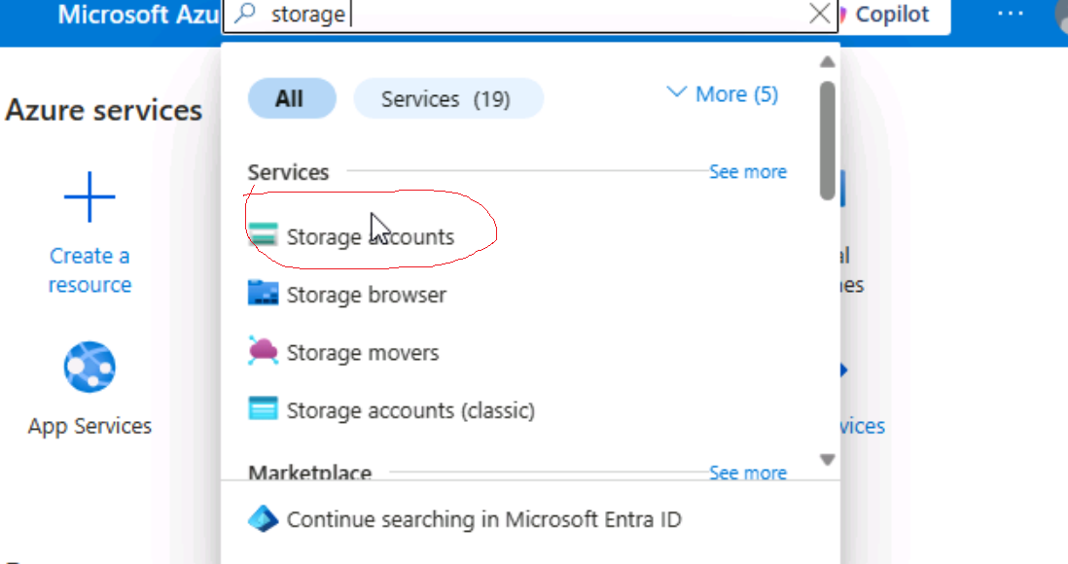

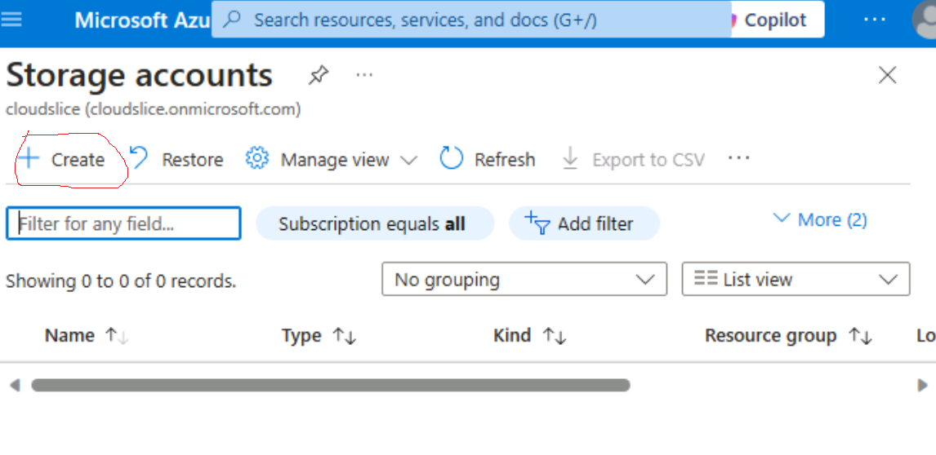

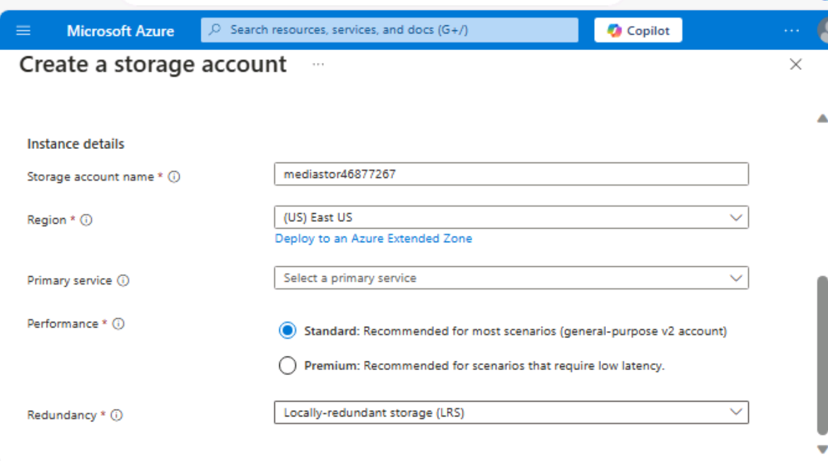

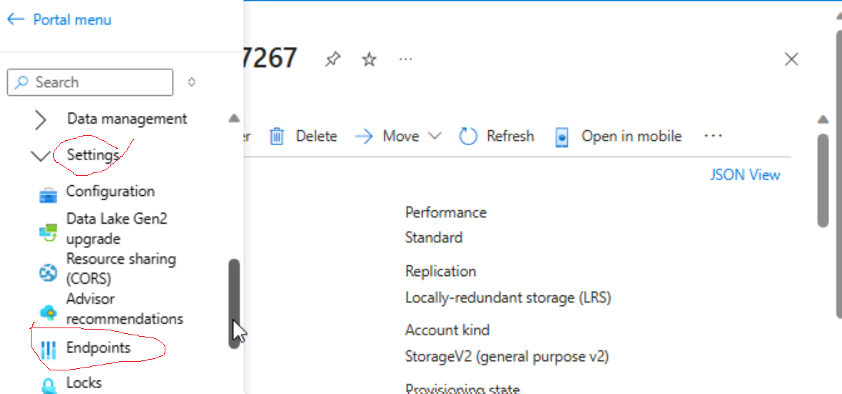

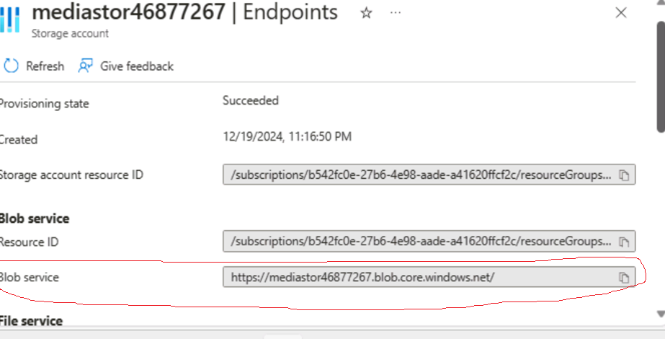

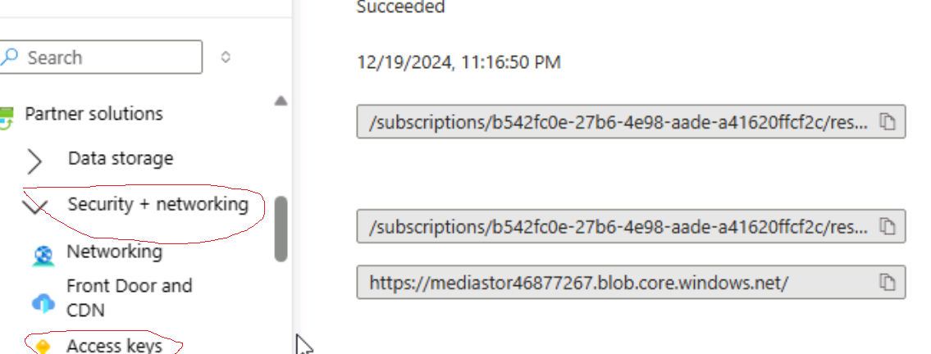

Endpoint : -

https://mediastor46877267.blob.core.windows.net/

key : -

A4clU7z94DA1bxQWXVmFWunDZVn5NwGweS67XgZOBsTRpP1ziFEUSOEmf9JHhjyeqgWQYRD5YTbf+ASt0bo+zg==

connectionString : -

DefaultEndpointsProtocol=https;AccountName=mediastor46877267;AccountKey=A4clU7z94DA1bxQWXVmFWunDZVn5NwGweS67XgZOBsTRpP1ziFEUSOEmf9JHhjyeqgWQYRD5YTbf+ASt0bo+zg==;EndpointSuffix=core.windows.net

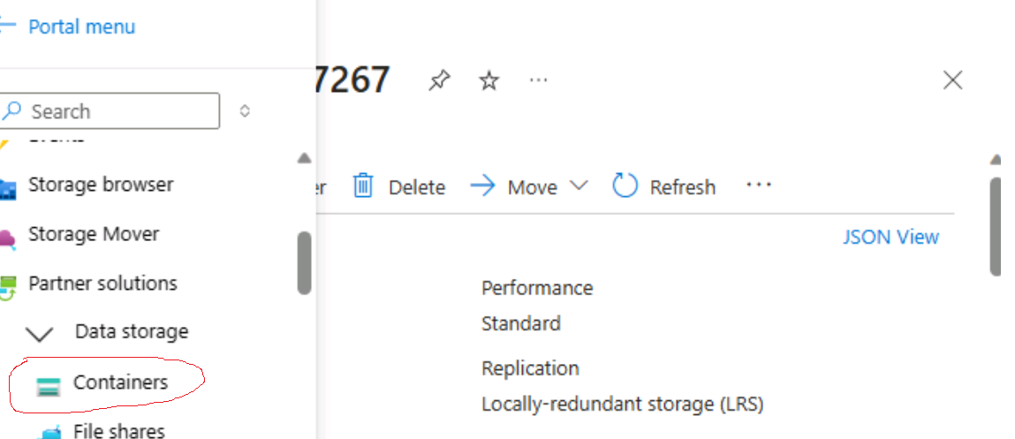

Task 1: Create storage account containers

1. On the **Storage account** blade, select the **Containers** link in the **Data storage** section.
2. In the **Containers** section, select **+ Container**.
3. In the **New container** pop-up window, perform the following actions, and then select **Create**:

| **Setting** | **Action** |
| --- | --- |
| **Name** text box | enter raster-graphics |
| **Public access level** drop-down list | Select **Private (no anonymous access)** |

1. In the **Containers** section, select **+ Container**.
2. In the **New container** pop-up window, perform the following actions and then select **Create**:

| **Setting** | **Action** |
| --- | --- |
| **Name** text box | enter compressed-audio |
| **Public access level** drop-down list | Select **Private (no anonymous access)** |

1. In the **Containers** section, observe the updated list of containers.

The following screenshot displays the configured settings on the **Create a storage account blade**.

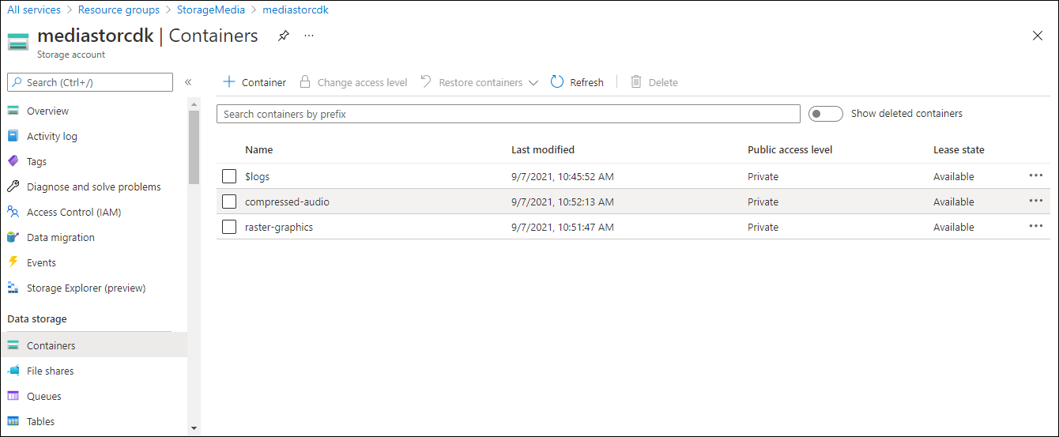

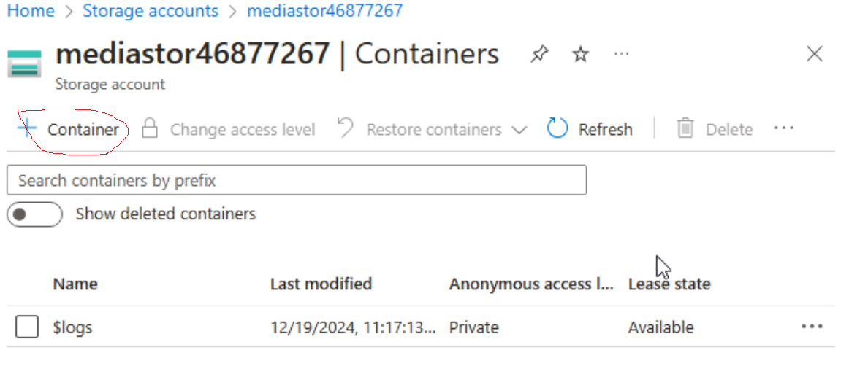

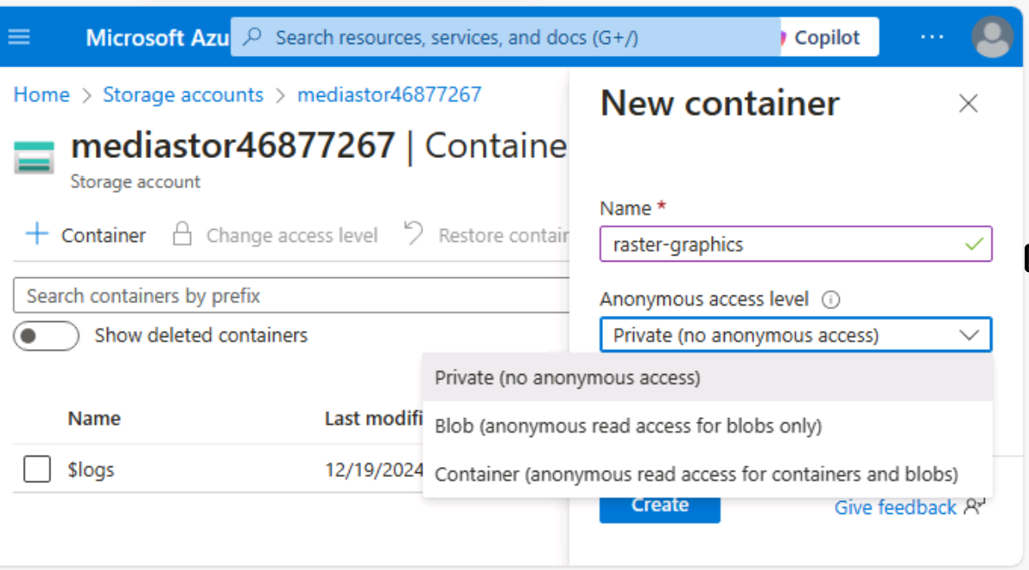

public static async Task Main(string[] args)

{

//The following line of code to create a new instance of the StorageSharedKeyCredential class by using the storageAccountName and storageAccountKey constants as constructor parameters

StorageSharedKeyCredential accountCredentials = new StorageSharedKeyCredential(storageAccountName, storageAccountKey);

//The following line of code to create a new instance of the BlobServiceClient class by using the blobServiceEndpoint constant and the accountCredentials variable as constructor parameters

BlobServiceClient serviceClient = new BlobServiceClient(new Uri(blobServiceEndpoint), accountCredentials);

//The following line of code to invoke the GetAccountInfoAsync method of the BlobServiceClient class to retrieve account metadata from the service

AccountInfo info = await serviceClient.GetAccountInfoAsync();

//Render a welcome message

await Console.Out.WriteLineAsync($"Connected to Azure Storage Account");

//Render the storage account's name

await Console.Out.WriteLineAsync($"Account name:\t{storageAccountName}");

//Render the type of storage account

await Console.Out.WriteLineAsync($"Account kind:\t{info?.AccountKind}");

//Render the currently selected stock keeping unit (SKU) for the storage account

await Console.Out.WriteLineAsync($"Account sku:\t{info?.SkuName}");

}